DUKE BIKE – E-COMMERCE MANAGEMENT SYSTEM
Seller and Inventory Management – DBMS Task
1. Create Seller and Inventory Tables
The Duke Bike Seller and Inventory Management System maintains seller details, product information, stock quantity, and product availability.
1.1 Seller Table
Attribute | Description | Key
Seller_ID | Unique identification number of the seller | Primary Key (PK)
Seller_Name | Name of the seller | —
Contact_No | Contact number of the seller | —
Email | Email address of the seller | —

1.2 Inventory Table
Attribute | Description | Key
Inventory_ID | Unique identification number of the inventory record | Primary Key (PK)
Seller_ID | Identifies the seller associated with the inventory | Foreign Key (FK)
Product_ID | Identifies the product in the inventory | Foreign Key (FK)
Stock_Quantity | Number of units currently available in stock | —
Stock_Status | Indicates whether the product is available or unavailable | —

2. Inserting Values
Seller and inventory records are inserted into the database using INSERT statements.
3. Establish Relationships Between Sellers, Products and Stock
The database establishes relationships between SELLER, PRODUCT, and INVENTORY using primary keys and foreign keys.
- SELLER → PRODUCT: One seller can provide multiple products.
- PRODUCT → INVENTORY: A product is connected to its inventory record.
- SELLER_ID in PRODUCT is a foreign key referencing SELLER.
- PRODUCT_ID in INVENTORY is a foreign key referencing PRODUCT.
SELLER
│
│ Supplies
↓
PRODUCT
│
│ Has Stock
↓
INVENTORY
4. Maintain Seller Product Information
Seller and product information is maintained using the related database tables and their key fields.
5. Assign Sellers to Products
Each product is assigned to a seller using Seller_ID.
6. Display Seller Product Information
Seller and product information can be displayed using queries joining the related tables.
7. Track Available and Unavailable Products
Product availability is determined from stock quantity: stock greater than zero is Available, while zero stock is Unavailable.
Inventory_ID | Product_ID | Product_Name | Stock_Quantity | Product_Status
1001 | 101 | Duke 125 | 25 | Available
1002 | 102 | Duke 200 | 0 | Unavailable
1003 | 103 | Duke 250 | 15 | Available
1004 | 104 | Duke 390 | 0 | Unavailable
1005 | 105 | Duke 790 | 30 | Available

8. Generate Inventory Status Report
The inventory status report displays seller name, product details, available stock, and product availability.
9. PL/SQL Inventory Status Report
A PL/SQL block can generate the inventory status report and display each record based on its stock quantity.
10. Actual SQL / PL-SQL Output Submitted
The following screenshots are the actual outputs provided for inclusion in the final submission. They are kept as output evidence without changing the displayed values.
Output Screenshot 1
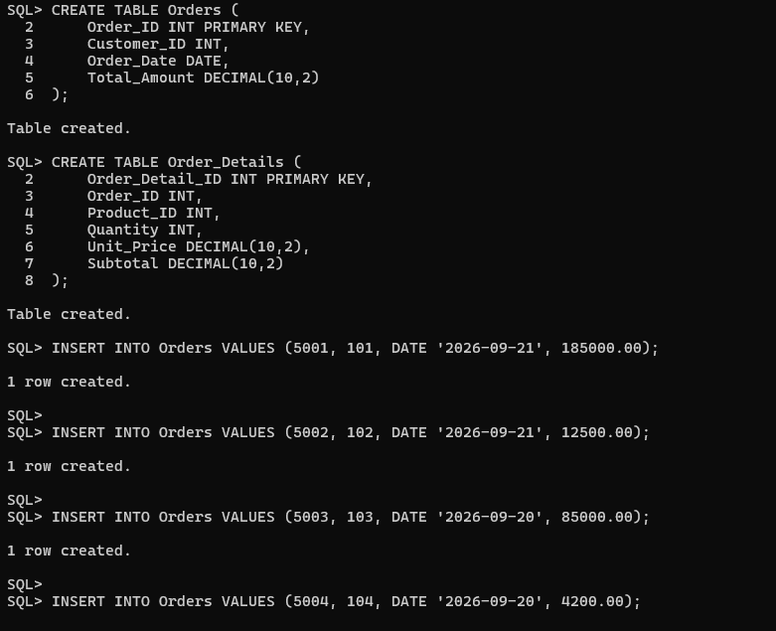

Output Screenshot 2
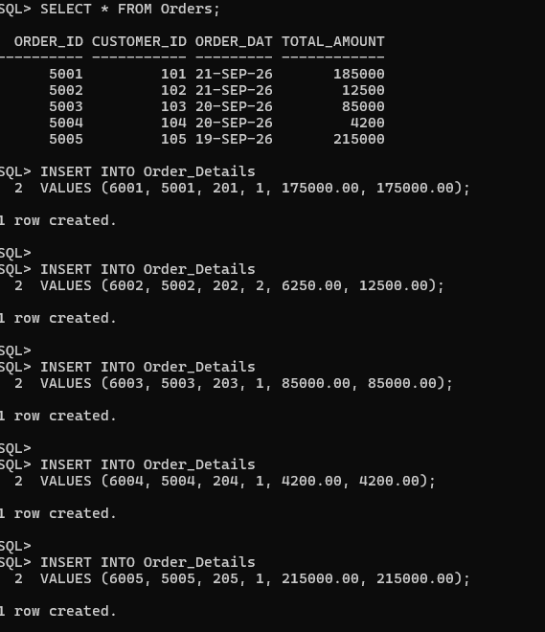

Output Screenshot 3
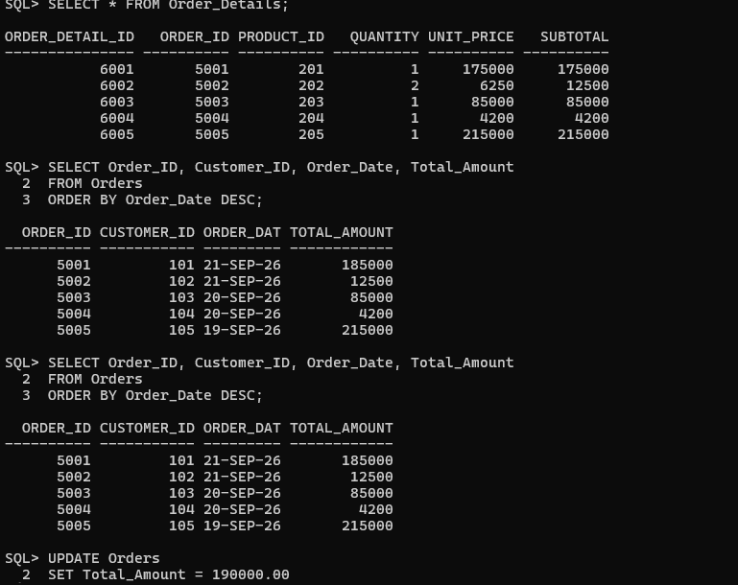

Output Screenshot 4
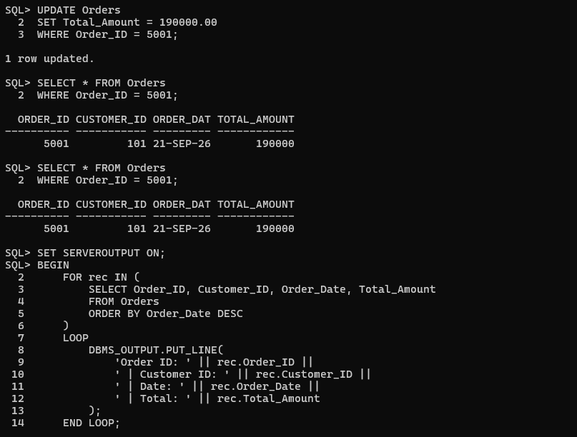

Output Screenshot 5
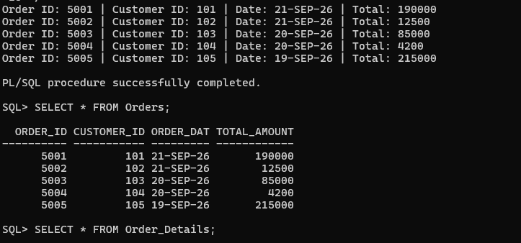

Output Screenshot 6
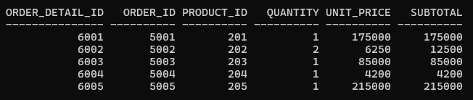
Conclusion
The Duke Bike DBMS task demonstrates table creation, data insertion, relationships, product availability tracking, and SQL/PL-SQL output generation.

